Project 2

Allen Worthley  
mworthley3@gatech.edu

# Figure 1

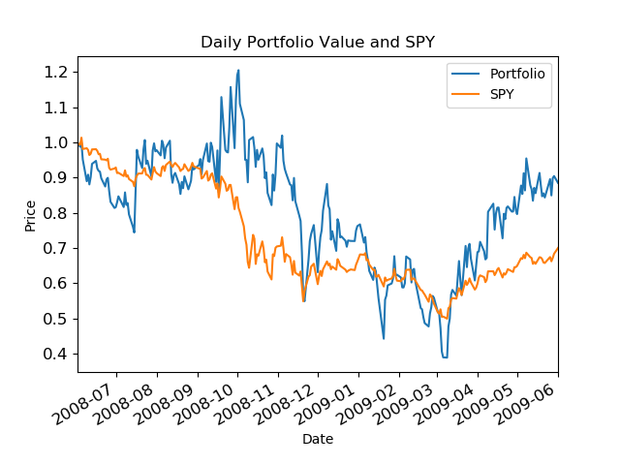

1. Chart shows the optimally allocation portfolio normalized daily value of a portfolio which consists of the tickers IBM, X, GLD, and JPM. The portfolio value is contrasted with a reference to SPY, the S&P 500 index.